

Department of Computer Information Systems

King Abdullah II School for Information Technology

The University of Jordan

**BRT cameras**

**2nd semester 2023**

Members:

|  |  |
| --- | --- |
| Zaid Aburasheid | 0201686 |
| Anan Alzaben | 0204379 |
| Omar Bashar Azizieh | 0207618 |
| Yazan Banikhalaf | 0189334 |
| Talal Mazen | 0189597 |

Supervisor: Dr. Rana Yousef

Table of Contents

Executive Summary: 6

1.0 Introduction: 7

1.1 Project Overview 7

1.2 The purpose of the Project 7

1.3 The Scope of the Work and Project Deliverables 7

1.4Local and Global Impact of The Proposed Solution 9

1.5Naming Conventions and Definitions (Terms, Acronyms, and Abbreviations) 10

2.0 Feasibility Study 11

2.1 Technical Feasibility 11

2.2perational Feasibility 11

2.3 Economic Feasibility 12

2.4 Schedule Feasibility 14

2.5 Legal Feasibility 14

3.0 Project Management plan 15

3.1 Project Organization 15

3.2 roles and responsibilities 16

3.3 Software Process Model 17

3.4Tools and Techniques 17

3.5 Work breakdown 18

3.5.n Project Tasks 18

3.2.2 Deliverables and Milestones 19

3.2.3 Resources needed (Skills, HW and SW) 20

3.2.4 Dependencies and Constraints 21

3.6 Assigning Team Members To Tasks 21

3.7 project schedule 22

3.8 Risk analysis 23

3.9 Monitoring, reporting, and controlling mechanisms for my project. 23

4.0 Software Requirements Specifications (SRS) 24

4.1 System Stakeholders and Requirements Sources 24

4.2 User Requirement Definition 25

4.3Use case Diagrams 25

4.4System Functional Requirement Specification 27

4.6 Non-Functional Requirements 29

4.6.1 Performance Requirements 29

4.6.2 Dependability Requirements 30

4.6.3 Security Requirements 31

4.6.4 Usability Requirements 32

4.6.5 Operational and Environmental Requirements 32

4.6.6 Maintainability Requirements 33

4.7 Data Requirements 33

5.0 Analysis and Design 34

5.1Activity Diagrams 34

5.2Sequence Diagrams 35

5.3class digram 36

5.4object to er mapping 37

5.5 Physical Database Design 38

5.6Architecture Design 38

5.6 Graphical User Interface Design(GUI) 39

6.0 41

6.2 database implementation 42

42

42

42

7.0 user manual 43

8.0 References: books and tools 45

# Executive Summary:

Our software project aims to improve the efficiency and safety of a dedicated bus lane using cameras mounted on traffic lights. The system will detect the presence of buses and count the number of passengers to optimize the traffic signal timings and provide real-time updates to passengers on the nearest bus and its arrival time. Additionally, the cameras can be used to perform other functions such as bus tracking, passenger counting, security monitoring, road maintenance, and environmental monitoring. By utilizing the available technology and data, the traffic management system can make informed decisions to improve the bus service, reduce congestion, and enhance the overall experience for passengers and drivers alike.

# Introduction:

## Project Overview

The goal of this project is to develop a traffic management software system for a dedicated bus lane using cameras mounted on traffic lights. The system will detect the presence of buses and count the number of passengers to optimize the traffic signal timings and provide real-time updates to passengers on the nearest bus and its arrival time.

## The purpose of the Project

The traffic management software project aims to improve the efficiency and safety of a dedicated bus lane through a system that utilizes cameras mounted on traffic lights to optimize traffic signal timings, detect buses, count passenger numbers, and provide real-time updates. Existing systems often rely on outdated technology and fixed-time signal plans, resulting in delays and congestion. The goal is to enhance user experience, reduce congestion, and improve efficiency and safety while ensuring flexibility and adaptability to changes in traffic flow and stakeholder needs.

## The Scope of the Work and Project Deliverables

**Business Requirements:**

The traffic management software system should be designed to achieve the following business requirements:

* Detect the presence of buses in a dedicated bus lane.
* Count the number of passengers on each bus.
* Optimize the frequency and capacity of buses based on passenger counts.
* Provide real-time updates to passengers on the nearest bus and its arrival time.
* Enhance overall user experience in the dedicated bus lane.
* Reduce congestion and improve the efficiency and safety of the bus lane.

**Constraints:**

* The software must be designed to work with the existing traffic infrastructure.
* The system must comply with local traffic laws and regulations.
* The software must be DEPENDABLE, secure, and easy to use.
* The system should be cost-effective and easy to maintain.

**Solution Alternatives:**

There are different solution alternatives to consider when developing the traffic management software system, including:

* Using advanced cameras and sensors to detect the presence of buses and count passenger numbers
* Integrating with existing traffic management systems to optimize traffic signal timings.
* Utilizing machine learning algorithms to adapt the system to changing traffic conditions

**Proposed Solution:**

The proposed solution is to develop a system that utilizes cameras mounted on traffic lights to detect the presence of buses, count passenger numbers, and optimize the frequency and capacity of buses. The software will integrate with existing traffic management systems to optimize traffic signal timings, and machine learning algorithms will be used to adapt the system to changing traffic conditions. The software will provide real-time updates to passengers on the nearest bus and its arrival time, enhancing overall user experience in the dedicated bus lane while reducing congestion and improving the efficiency and safety of the bus lane.

## 1.4Local and Global Impact of The Proposed Solution

**Local Impact:**

Improved user experience and reduced travel times for commuters using the dedicated bus lane, leading to increased ridership and reduced congestion.

Improved safety and reduced accidents in the dedicated bus lane, leading to fewer injuries and fatalities.

Reduced greenhouse gas emissions due to more efficient bus scheduling and reduced traffic congestion.

**Global Impact:**

Increased adoption of smart traffic management solutions can lead to improved traffic management and reduced congestion in urban areas globally.

Reduced greenhouse gas emissions from more efficient traffic management can help reduce the carbon footprint of transportation and contribute to global efforts to combat climate change.

Improved safety of transportation systems in urban areas can reduce the number of traffic-related injuries and fatalities globally.

Overall, the proposed traffic management software solution can have significant positive impacts both locally and globally by improving traffic management, reducing congestion, increasing safety, and reducing greenhouse gas emissions.

Top of Form.

## 1.5Naming Conventions and Definitions (Terms, Acronyms, and Abbreviations)

Terms:

* Traffic management software: A system that utilizes cameras mounted on traffic lights to optimize traffic signal timings, detect buses, count passenger numbers, optimize bus frequency and capacity, and provide real-time updates.
* Dedicated bus lane: A road lane that is reserved exclusively for buses.
* Machine learning: A type of artificial intelligence that enables computers to learn and improve performance on a specific task without being explicitly programmed.
* User experience: The overall experience of a person using a product or service, including ease of use, efficiency, and satisfaction.

Acronyms and Abbreviations:

* BRT: Bus Rapid Transit
* CCTV: Closed-circuit television
* GPS: Global Positioning System
* IoT: Internet of Things
* API: Application Programming Interface
* ML: Machine Learning

# 2.0 Feasibility Study

## 2.1 Technical Feasibility

1. Camera Placement and Coverage: The project requires cameras to be mounted on traffic lights to detect buses and count passenger numbers. The placement of cameras and their coverage area must be carefully planned to ensure accurate detection and counting.
2. Image Processing: The system must be able to process camera images in real-time using machine learning algorithms to detect buses and count passengers. This requires the use of high-performance computing devices and specialized software libraries for image processing and machine learning.
3. Data Security: The system will collect sensitive data such as bus schedules, passenger counts, and traffic signal timings. Robust security measures must be implemented to protect this data from unauthorized access, breaches, and cyber-attacks.
4. System Maintenance: The system must be regularly maintained to ensure proper functioning and accuracy. This includes software updates, hardware maintenance, and regular checks on the camera and sensor systems.
5. User Interface: The system should have an easy-to-use user interface to allow operators to access and analyze real-time data, manage bus schedules, and adjust the system as needed.

## 

## 2.2perational Feasibility

1. User Acceptance: The project aims to improve the traffic flow and provide real-time bus schedules to passengers. Therefore, it is essential to involve bus drivers, passengers, and traffic management officials in the project planning process to ensure that the system meets their needs and expectations.
2. Staff Training: The successful implementation of the project requires staff to be trained to operate and maintain the system. Bus drivers and traffic management officials will need to be trained on how to use the system, interpret data, and respond to system alerts.
3. System Integration: The system should be integrated with existing traffic management systems to ensure seamless operation and minimize disruption to existing operations. This includes the integration with traffic signal control systems and communication systems.
4. Cost-Effectiveness: The project should be cost-effective, with benefits outweighing the cost of implementation and maintenance. This requires a careful analysis of the costs and benefits of the project, including the cost of hardware and software, installation and maintenance costs, and potential cost savings from improved traffic flow.
5. Legal and Regulatory Compliance: The system must comply with relevant laws and regulations, including data protection laws and traffic regulations.

## 2.3 Economic Feasibility

**1-Totel Economic Cost:**

**2-Expenses Costs:**

|  |  |  |
| --- | --- | --- |
|  | Cost | Number |
| Camera equipment costs | **70 JD** | **1 camera** |
| Installation costs | **150JD** | **1 camera** |
| System integration costs | **1000JD** | **All system** |
| Maintenance and operation costs | **75JD** | **1 camera** |
| Training and workforce costs: | **300 JD** | **1 camera** |
| Potential revenue sharing or usage fees | **100** | **1 camera** |
| Regulatory compliance costs | **150** | **1 camera** |
|  |  |  |

* **Total costs for each camera:**
* 70 + 150+ 75 + 300 + 100 + 150 = 845
* + the system integration 100000
* **Expenses:**

Annual maintenance: 500 JD/ C

Ensure that the system work: 300 JD.

Total = 800 JD.

**-Development Cost:**

**-Personal Costs**

|  |  |  |  |
| --- | --- | --- | --- |
|  |  |  |  |
| 1 System Analyst | **30 JD** | **20 hr.** | **600 JD** |
| 1 System Administrator | **16 JD** | **30 hr.** | **480 JD** |
| 2 Programmer | **15 JD** | **130 hr.** | **1950 JD** |
| 1 GUI designer | **10 JD** | **25 hr.** | **250 JD** |
| 1 Database Specialist | **10 JD** | **15 hr.** | **150 JD** |
| Total: 3430 JD |

|  |  |
| --- | --- |
| Hardware & Software | **Cost** |
| **1 Computers** | **750 JD** |
| **1 DBMS Software** | **450 JD** |
| **1 Development Server** | **700 JD** |
| **Total** | **1900 JD** |

## 2.4 Schedule Feasibility

Any delay after the deadline will result in the entire project being rejected. Therefore, feasibility scheduling in this case is an important factor. Accordingly, our site requirements have been carefully defined so that we can implement the project within the acceptable time frame granted to us.

## 2.5 Legal Feasibility

1. Data Protection: The project must comply with the Personal Data Protection Law No. 30 of 2018 in Jordan, which governs the collection, processing, storage, and use of personal data. The law requires obtaining consent for data processing, implementing appropriate security measures, and notifying data subjects of any breaches.
2. Intellectual Property Rights: The project must respect intellectual property rights in Jordan, which are governed by the Jordanian Copyright Law and the Jordanian Trademark Law. The laws provide for the registration and protection of copyrights and trademarks, and any use of third-party intellectual property must be properly licensed and authorized.
3. Liability and Responsibility: The project should define liability and responsibility for any potential accidents, damages, or other issues that may arise from the use of the system, in accordance with Jordanian civil law. The system operators, maintenance personnel, and other stakeholders must comply with relevant regulations and standards.
4. Compliance with Traffic Regulations: The project must comply with relevant traffic regulations in Jordan, which are governed by the Jordanian Traffic Law. The law regulates traffic signal control, pedestrian safety, and other aspects of traffic management, and the system should be designed to enhance safety and efficiency on the road while complying with relevant regulations.
5. Accessibility: The project must ensure accessibility for all users in Jordan, including individuals with disabilities, in accordance with the Jordanian Persons with Disabilities Law No. 20 of 2017. The law requires public facilities and services to be accessible to individuals with disabilities, and the traffic management software project should comply with these requirements.

# 3.0 Project Management plan

## 3.1 Project Organization

1. Project Sponsor: This is the person or group that provides the funding and support for the project. They oversee the project and ensure that it aligns with the business objectives.
2. Project Manager: This is the person responsible for managing the project and ensuring that it is delivered on time, within budget, and to the required quality standards. They are responsible for communication with stakeholders, risk management, and project reporting.
3. Technical Team: This team is responsible for developing and implementing the software solution. It may include software engineers, data analysts, user interface designers, and other technical specialists.
4. Operations Team: This team is responsible for maintaining and supporting the software solution after it has been implemented. It may include system administrators, technical support specialists, and other operations personnel.
5. Stakeholders: This includes all individuals or groups who have an interest or are affected by the project, including government agencies, transportation authorities, bus operators, and the public.

## 3.2 roles and responsibilities

|  |  |
| --- | --- |
| role | Description |
| Project Manager | responsible for overall project management, including planning, scheduling, budgeting, and risk management. |
| Software Developer | responsible for designing, developing, and testing software solutions that meet project requirements. |
| Hardware Engineer | responsible for designing, implementing, and maintaining the hardware infrastructure needed for the project. |
| Data Analyst | responsible for analyzing and interpreting data collected by the cameras and providing insights to optimize traffic flow. |
| Quality Assurance (QA) Specialist | responsible for ensuring that the software solution meets quality standards and performs as expected. |
| User Experience (UX) Designer | responsible for designing and testing the user interface to ensure that it is intuitive and easy to use. |
| Deployment Engineer | responsible for deploying the software solution and ensuring that it is properly integrated with the hardware infrastructure. |
| Technical Writer | responsible for documenting the software solution, including user manuals, technical specifications, and system documentation. |

## 3.3 Software Process Model

Agile model is based on iterative and incremental development, with a focus on delivering working software in short cycles. This approach allows for continuous feedback and adjustments to be made throughout the development process, making it easier to adapt to changing requirements or new information.

In an Agile model, the development team works closely with stakeholders, such as end-users, to ensure that the system meets their needs and expectations. The team collaborates on the development of user stories, which describe the desired functionality of the system from the user's perspective. These user stories are then used to prioritize development tasks and guide the iterative development process.

Agile also emphasizes frequent testing and quality assurance, with the goal of catching and addressing issues early in the development process. Testing is integrated throughout the development process, with automated testing tools used to help identify and resolve defects quickly.

Overall, the Agile model can help ensure that your project is completed on time, within budget, and with high quality. However, it's important to keep in mind that Agile requires a high degree of collaboration and communication among team members, as well as a willingness to adapt to changing requirements or feedback.

Top of Form

## 3.4Tools and Techniques

|  |
| --- |
| Computer vision libraries and frameworks: Your project involves using cameras to detect buses and count the number of passengers, so you will need to use computer vision libraries and frameworks such as OpenCV or TensorFlow. |
| Traffic simulation software: You may want to use traffic simulation software like SUMO or VISSIM to model the traffic flow and test your solution before deploying it in the real world. |
| GPS and mapping APIs: To provide users with information about the nearest bus and estimated arrival time, you may want to use GPS and mapping APIs like Google Maps or Map box. |
| Database management systems: You will need a database management system to store information about the buses, their routes, and passenger counts. Popular options include MySQL, PostgreSQL, or MongoDB. |
| Real-time messaging platforms: You may want to use a real-time messaging platform like MQTT or WebSocket to provide real-time updates to users about bus arrival times. |
| Continuous Integration/Continuous Delivery (CI/CD) tools: CI/CD tools like Jenkins or GitLab can be used to automate the software build, testing, and deployment process. |
| Agile development methodologies: Agile methodologies like Scrum or Kanban can be used to manage the development process and ensure that the project is meeting its objectives. |

## 3.5 Work breakdown

### 3.5.n Project Tasks

|  |  |  |
| --- | --- | --- |
| Task number | Task | Description |
| T1 | Idea gathering | This task involves brainstorming and researching to generate and refine your project idea. |
| T2 | Feasibility study | This task involves assessing the technical, operational, economic, and legal feasibility of the project to determine if it is viable. |
| T3 | Gathering requirements | This task involves identifying and documenting the specific features and functionality that the system should have to meet the needs of users. |
| T4 | System analysis | This task involves analyzing the requirements and identifying any potential issues or challenges that may arise during development. |
| T5 | System design | This task involves creating a high-level design for the system, including the architecture, components, and interfaces. |
| T6 | Implementation | This task involves writing and testing the code for the system components and integrating them into a functional system. |
| T7 | Testing | This task involves testing the system to ensure that it meets the requirements and functions as expected. |
| T8 | Maintenance and support | This task involves providing ongoing maintenance and support to the system to ensure that it continues to function properly and meet the needs of users. |

### 3.2.2 Deliverables and Milestones

**Deliverables:**

* Feasibility study report
* Requirements document
* System design document
* Source code and documentation
* User manual and training materials
* Testing and validation reports
* Final project report

**Milestones:**

* Completion of feasibility study and approval of project plan
* Completion of requirements gathering and approval of requirements document
* Completion of system analysis and design and approval of system design document
* Completion of implementation and testing of system components
* Completion of system testing and validation
* User acceptance testing and approval.
* Project completion and final report submission

### 3.2.3 Resources needed (Skills, HW and SW)

**Skills**:

* Software development skills (e.g., programming, software design, testing, documentation)
* Systems analysis and design skills
* Project management skills
* Knowledge of computer networks and communication protocols
* Understanding of image and video processing techniques

**Hardware:**

* Cameras for detecting buses and tracking traffic
* Server or cloud infrastructure for processing data and running the system.
* Network infrastructure for communication between cameras and servers

**Software:**

* Integrated Development Environment (IDE) for programming (e.g. Eclipse, Visual Studio)
* Image and video processing software (e.g., OpenCV, MATLAB)
* Database management system (e.g., MySQL, Oracle)
* Web development frameworks (e.g., Node.js, React)

### 3.2.4 Dependencies and Constraints

**Dependencies:**

|  |
| --- |
| * Availability of necessary hardware, software, and skills |
| * Availability of power and internet connectivity |
| * Collaboration and communication between team members |
| * Compliance with relevant legal and regulatory requirements |
| * Availability of funding and other resources |

**Constraints:**

|  |
| --- |
| * Time constraints for project completion |
| * Budget constraints for acquiring necessary resources |
| * Technical limitations of hardware and software |
| * Physical constraints of the environment (e.g., weather, traffic conditions) |
| * Compatibility issues between different hardware and software components |

## 3.6 Assigning Team Members To Tasks

|  |  |  |  |  |  |
| --- | --- | --- | --- | --- | --- |
| Tasks | Description | Start time | Duration | Dependcies | Staff |
| T1 | Starting the project | 3 Apr | 10 Days | None | All members |
| T2 | Technical & operational feasibility | 13 Apr | 7 Days | T1, (M1) | Anan, Yazan |
| T3 | Economic & Schedule Feasibility | 20 Apr | 7 Days | M1 | Omar, Zaid |
| T4 | Identifying Stakeholder & Data gathering techniques | 25 Apr | 5 Days | T2, T3, (M2) | Talal, Zaid, Anan |
| T5 | Functional & Nonfunctional requirements & Domain | 30 Apr | 12Days | T4, (M3) | All Members |
| T6 | Risk Management | 12 May | 9 Days | M3 | Zaid |
| T7 | System Modeling | 21 May | 15 Days | T5 | All members |
| T8 | Implementation | 5 June | 10 Days | T7 | Yazan, Zaid, Anan |
|  |  |  |  |  |  |

* The project should be done in duration of 70 Days.

## 3.7 project schedule

1.. Pert Diagram:

3.Gant Chart:

Figure Grant chart

## 3.8 Risk analysis

|  |  |  |
| --- | --- | --- |
| Risk | Probability | Effect |
| Organizational financial problem | Moderate | Serious |
| Find qualified cloud developers is not an easy thing. | High | Tolerable |
| Changes to requirements that require major design rework | Very high | Serious |
| The time required to develop the software is underestimated | High | Serious |
| The size of the software is underestimated | Low | Serious |
| Open sources libraries may not cover software needs or have security defects. | High | Tolerable. |
| Privacy and security risks the system could be vulnerable to cyber-attacks or  unauthorized access, | Low | Serious. |
| Officers may face difficulties in using the system properly. | Low | Tolerable. |
| Operational risks | Low | Serious |
| Stakeholder risks: bus drivers, passengers, or community members. | Low | Serious |

## 3.9 Monitoring, reporting, and controlling mechanisms for my project.

1. Regular team meetings to review progress, identify issues, and discuss potential solutions.
2. Milestone tracking to ensure that the project is progressing as planned.
3. Use of project management software to track progress and communicate with team members.
4. Communication with stakeholders, including regular updates on project status and any issues or risks identified.
5. Regular review of project deliverables to ensure they meet quality standards.
6. Use of change management processes to manage changes to project scope or requirements.
7. Use of risk management processes to identify and mitigate project risks.

# 4.0 Software Requirements Specifications (SRS)

## 4.1 System Stakeholders and Requirements Sources

|  |  |
| --- | --- |
| Stakeholders | Description |
| Bus riders | will use the system to navigate and plan their trips |
| Bus drivers | will receive notifications and updates on their routes and schedules |
| Bus companies | will benefit from increased efficiency and customer satisfaction |
| Government transportation authorities | may regulate and oversee the system |
| Developers | design and implement the software and hardware components of the system |
| Maintenance and support personnel | will ensure the system runs smoothly and address any issues that arise. |

|  |
| --- |
| 1.Users:   * Feedback from surveys and focus groups. * User interviews and observations * Requests for features and improvements * Complaints and issues reported through customer support channels. |
| 2.Bus drivers:   * Surveys and feedback from drivers * Interviews and observations of drivers on the job * Requests for equipment and tools to improve their work. * Reports of safety hazards or road conditions that affect their ability to drive safely |
| 3.Transportation company:   * Company policies and standards for safety and service quality * Compliance with local regulations and laws * Business objectives, such as increasing profitability or reducing costs. * Performance metrics and KPIs related to customer satisfaction and safety |
| 4.Local government:   * Traffic and safety regulations * Policies related to public transportation. * Budget constraints and funding sources for transportation projects * Reports of road and infrastructure issues or hazards that affect public safety |
| 5.Third-party app developers:   * Technical documentation and APIs for integrating with your system. * User feedback and feature requests for their own apps * Business goals and objectives, such as increasing user engagement or revenue * Compliance with relevant data privacy and security regulations. |

## 4.2 User Requirement Definition

1. The user should be able to input their destination and receive a list of recommended routes, including the nearest station and the next available bus.
2. The user should be able to view real-time bus schedules and receive alerts for delays or cancellations.
3. The user should be able to search for specific bus routes and view their schedules and stops.
4. The user should be able to set personal preferences, such as preferred modes of transportation or specific stations or routes.
5. The user should be able to save favorite routes and receive notifications for any changes or updates.
6. The user interface should be intuitive and user-friendly, with clear navigation and easy-to-read schedules.
7. The system should be accessible from both web and mobile platforms.
8. The system should be dependable and able to handle a large volume of users and data.
9. The system should be scalable and adaptable to future changes or updates in the transportation network.
10. The system should ensure the privacy and security of user data.
11. After all the users need to get fast and safe ride.

## 4.3Use case Diagrams

**Use Case Diagram 1: send feedback.**

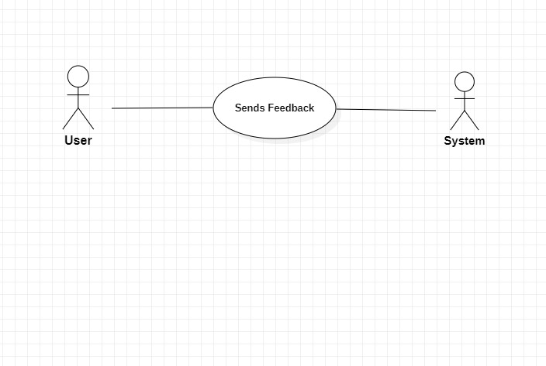

|  |
| --- |
| **Use Case: Send Feedback** |
| Actors: User |
| Description: Allows the user to send feedback to the system |
| Preconditions: User is registered and logged in |
| Postconditions: Feedback is successfully submitted |

|  |  |  |
| --- | --- | --- |
| steps | Actor | system |
| 1 | User selects "Send Feedback." | Presents feedback form to the user. |
| 2 | User fills in feedback and User submits feedback. | Stores feedback in the system  Notifies user of successful feedback submission |

**Alternative Flows:**

1.User cancels feedback submission:

* The system discards entered feedback and ends use case.

2.Validation errors with feedback details:

* The system displays error messages for the user to correct.

3.Technical issues during submission:

* The system displays an error message, allowing the user to retry or contact support.

**Use Case Diagram 2: Track Bus Location**

|  |
| --- |
| **Use Case: Track Bus Location** |
| Actors: User |
| Description: Allows the user to track the location of a bus |
| Preconditions: User is registered and logged in |
| Postconditions: User can view the real-time bus location |

|  |  |  |
| --- | --- | --- |
| **Steps** | **Actor** | **System** |
| 1 | User selects "Track Bus." | Displays a list of available bus routes. |
| 2 | User selects a bus route. | Retrieves the real-time location of the bus and displays the bus location on a map to the user |
| 3 | User views bus location | Periodically updates the bus location on the map. |

**Alternative Flows:**

1.No buses available for the selected route:

* The system displays a message indicating no buses are currently operating on the selected route.

2.Technical issues with bus location retrieval:

* The system displays an error message, allowing the user to retry or contact support.

3.User cancels bus tracking:

* The system stops updating the bus location on the map and returns the user to the previous screen.

## 4.4System Functional Requirement Specification

|  |  |
| --- | --- |
| Requirement | Description |
| User Registration | The system should allow users to register for the service with their personal information and create a login ID and password. Users can be of two types, passengers, and bus operators. |
| User Login | Users should be able to log in using their card ID and password. |
| User Profile | The system should maintain user profiles, including personal information and travel preferences. |
| User Verification | The system should verify the user's identity during registration and log-in using a verification process, such as email verification or phone verification |
| Real-time Tracking. | The system should track the location of buses in real-time using GPS or other tracking technologies |
| Route Optimization | The system should optimize bus routes based on passenger demand, traffic conditions, and other factors. |
| Schedule Management | The system should manage the schedules of buses and notify users of any changes or delays. |
| Route Visualization | The system should provide a map-based visualization of bus routes and stops. |
| ETA Estimation | The system should estimate the estimated time of arrival (ETA) of buses at each stop based on real-time tracking and other factors. |
| Arrival Notification | The system should notify passengers of the arrival of buses at their desired stops through SMS, push notifications, or other means. |
| Payment Gateway Integration | The system should integrate with payment gateways to enable passengers to pay for their tickets online. |
| Fare Calculation | The system should calculate fares based on the distance traveled, the number of stops, and other factors. |
| Fare Management | The system should manage fare information, including discounts, promotions, and refunds. |
| Payment Verification | The system should verify the payment information of users during ticket purchase and refund processes. |
| Feedback Management | The system should allow users to provide feedback on their travel experience, including ratings and comments. |
| Feedback Analysis | The system should analyze user feedback to identify areas for improvement and make changes accordingly |
| Customer Support | The system should provide customer support to users to resolve any issues or complaints. |
| Admin Dashboard | The system should provide an admin dashboard to manage users, buses, schedules, fares, and other system settings. |
| Bus Operator Management: | The system should manage bus operators, including their contact information, bus details, and schedules. |
| Analytics and Reporting | The system should provide analytics and reporting on passenger demand, bus occupancy, revenue, and other key metrics. |
| System Maintenance | The system should allow administrators to perform system maintenance tasks, such as backups and updates. |
| Authentication and Authorization | The system should authenticate and authorize users, bus operators, and administrators based on their roles and permissions. |
| Data Encryption | The system should encrypt sensitive user information, such as passwords and payment details, to ensure data security. |
| Privacy Policy: | The system should provide a clear and comprehensive privacy policy that outlines how user data is collected, stored, and used. |
| Seat Selection | Passengers should be able to select their preferred seats during the booking process. |
| Ticket Cancellation | The system should allow passengers to cancel their tickets and provide refunds if applicable. |
| Lost and found. | The system should provide a lost and found service for items left on the bus. |
| Data Backup and Recovery | The system should perform regular data backups and have a recovery plan in case of system failure or data loss. |

## 4.6 Non-Functional Requirements

### 4.6.1 Performance Requirements

* The system should have high accuracy in detecting the presence of buses and counting the number of passengers.
* The system should provide real-time updates to passengers on the nearest bus and its arrival time without any significant delay.
* The system should optimize the traffic signal timings quickly and efficiently to reduce congestion.
* The cameras should be able to capture high-quality images and videos to ensure accurate tracking and monitoring of buses and passengers.
* The system should be able to handle a large amount of data in real-time without any system crashes or slowdowns.
* The system should have a fast response time to any changes in the traffic conditions or bus schedules to ensure timely updates to passengers and drivers.
* The system should be scalable to accommodate future expansions or changes in the system.

### 4.6.2 Dependability Requirements

|  |  |
| --- | --- |
| * Safety | The software system should be designed to prioritize safety, especially since it is intended to be used on the road. It should be able to detect and respond appropriately to any potential hazards or issues that may arise during operation. |
| * Availability | The system should be available to users whenever they need it, and it should be designed to minimize downtime or disruptions. Users should be able to rely on the system to provide accurate real-time updates on the nearest bus and its arrival time. |
| * Performance | The system should perform efficiently, quickly, and accurately. This means that it should be able to detect buses and count passengers in real-time, optimize traffic signal timings, and perform other functions accurately and quickly. |
| * Reliability | The system should be reliable and free from errors or failures. It should be designed to handle unexpected events or errors gracefully and recover from them without causing any disruptions or compromising the system's functionality. |
| * Security | The system should be secure and protected from unauthorized access, data breaches, or cyber-attacks. This includes measures to protect user data, sensitive information, and system resources from unauthorized access or tampering |
| * Maintainability | The system should be easy to maintain, update, and upgrade. It should be designed to facilitate easy debugging, error correction, and feature enhancement |

### 

### 4.6.3 Security Requirements

|  |  |
| --- | --- |
| Access control | The system should restrict access to authorized personnel only and implement appropriate authentication and authorization mechanisms to prevent unauthorized access to the data and functionalities of the system. |
| Data protection: | The system should implement measures to ensure the confidentiality, integrity, and availability of the data collected and processed by the cameras and the traffic management system. This includes encryption, backup and recovery procedures, and data retention policies. |
| Monitoring and auditing | The system should be able to log and track all user activities and system events and provide audit trails for forensic purposes. The system should also implement real-time monitoring and alerting mechanisms to detect and respond to security incidents and anomalies. |
| Physical security | The cameras and other hardware components of the system should be physically secured against theft, tampering, or damage. This includes installing the cameras in secure locations, using tamper-evident seals, and implementing physical access controls to the system components. |
| Cybersecurity | The system should be protected against cyber-attacks such as malware, hacking, and denial-of-service attacks. This includes implementing firewalls, intrusion detection and prevention systems, and security patches and updates. |
| Privacy | The system should respect the privacy rights of the passengers and other individuals who may be captured by the cameras. This includes implementing privacy-by-design principles, obtaining consent and informing the public about the data collection and processing practices, and complying with applicable privacy regulations and standards. |
| Incident response | The system should have a documented and tested incident response plan that outlines the procedures for handling security incidents and restoring the system to normal operation. The plan should include roles and responsibilities, communication channels, escalation procedures, and post-incident review and lessons learned. |

### 4.6.4 Usability Requirements

|  |  |
| --- | --- |
| * User-friendly interface | The system should have a user-friendly interface that is easy to use and understand for both passengers and traffic management personnel. |
| * Accessible information | The system should provide real-time updates on bus arrival times, bus locations, and passenger counts to ensure passengers can plan their journeys effectively. |
| * Clear and concise communication | The system should communicate important information, such as delays or route changes, in a clear and concise manner to avoid confusion. |
| * Reliable and consistent performance | The system should be reliable and consistently perform its intended functions to ensure passengers can rely on it for accurate information. |
| * Mobile compatibility | The system should be accessible via mobile devices to allow passengers to access information on-the-go. |
| * Customizable settings | The system should allow users to customize their preferences, such as language and notification settings, to ensure a personalized experience. |
| * Security and privacy | The system should ensure the security and privacy of user data to protect sensitive information. |
| * Compatibility with existing infrastructure | The system should be compatible with existing infrastructure to minimize disruption and maximize efficiency. |
| * Integration with other systems: | The system should be able to integrate with other transportation systems, such as ticketing systems, to enhance the overall transportation experience. |

### 4.6.5 Operational and Environmental Requirements

**1-Operational Requirements:**

* The cameras must be mounted on traffic lights located on the dedicated bus lane.
* The cameras should be able to detect the presence of buses accurately and consistently.
* The system should be able to count the number of passengers on the buses in real time.
* The system should optimize the traffic signal timings based on the data collected by the cameras.
* The system should provide real-time updates to passengers on the nearest bus and its arrival time.
* The cameras should be able to track buses and perform passenger counting, security monitoring, road maintenance, and environmental monitoring.

**2-Environmental Requirements:**

* The cameras must be able to operate in different weather conditions such as rain, snow, and fog.
* The cameras should be durable and able to withstand temperature fluctuations.
* The cameras must be able to operate in low light conditions.
* The system should have a backup power source to ensure continuous operation during power outages.
* The cameras must comply with environmental regulations in operation.

### 4.6.6 Maintainability Requirements

* The system should be designed with modularity in mind to allow for easy maintenance and updates.
* The code should be well-documented with comments and clear naming conventions to enhance readability and maintainability.
* The system should be designed to handle changes in technology and data sources over time.
* The system should be scalable and able to handle increased traffic volume without compromising performance or reliability.
* The system should be designed with a clear error handling strategy to quickly identify and resolve issues.

## 4.7 Data Requirements

* The system should have a secure and reliable data storage solution that can handle large volumes of data.
* The data should be properly formatted, cleaned, and validated to ensure accuracy and consistency.
* The system should use real-time data to provide accurate information to passengers on bus arrival times and other relevant information.
* The data collected should be analyzed to identify patterns and trends to inform decision-making for traffic management.
* The system should comply with relevant data privacy and security regulations to protect the privacy of passengers and drivers.

# Analysis and Design

## 5.1Activity Diagrams

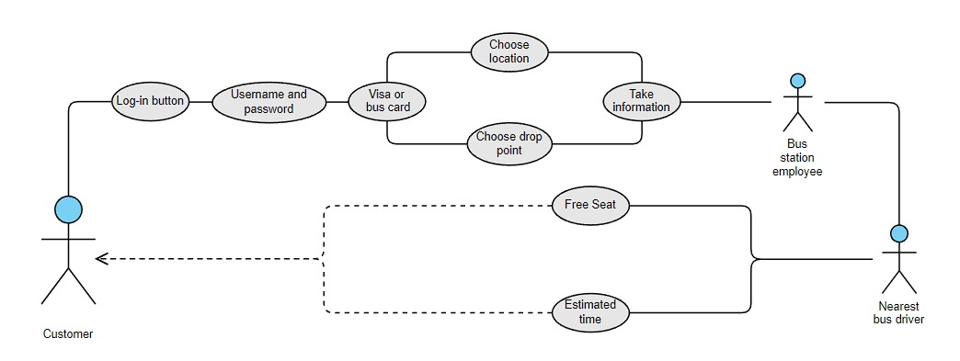

|  |  |
| --- | --- |
| Actor(customer) | Citizen and passengers |
| Data | Actor location and destination information will be sent to the station to get analysis.  Buss station will send notification to the nearest bus driver from the actor.  The bus driver will send to the rider if there is free seat and the estimated time needed to arrive. |
| Bus driver | Will send the estimated time and if their free seat to the rider. |
| Station | Do analysis on the destination and the location. |
|  |  |

## 5.2Sequence Diagrams

Sequence Diagram: Track Bus Location

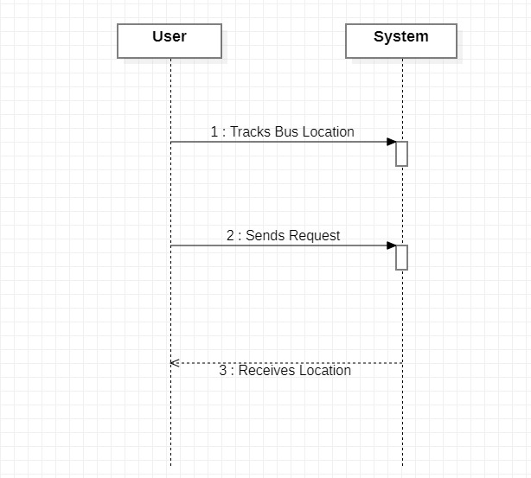

Sequence Diagram: provide feedback.

## 5.3class digram

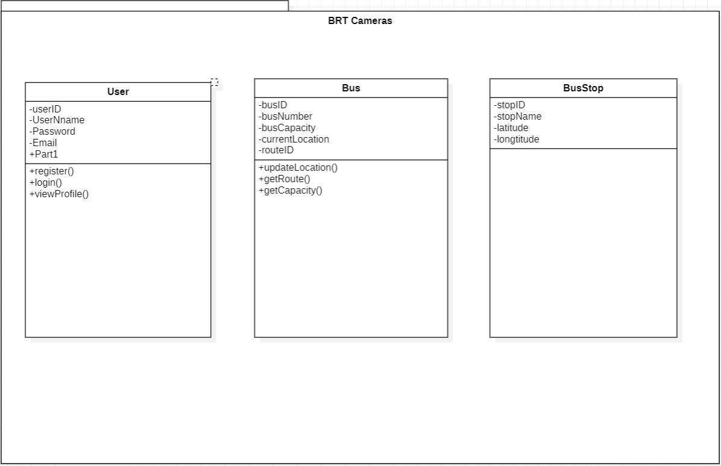

## 5.4object to er mapping

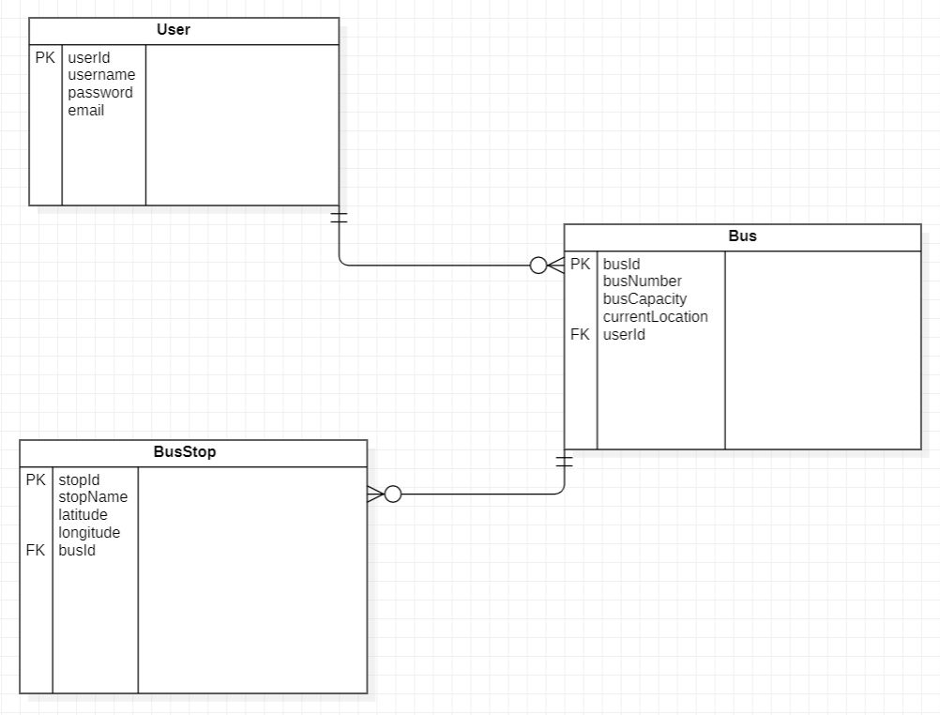

**Relations description:**

1.User Table:

. One-to-Many relationship with the Bus Table: Each user can be associated with multiple buses (one user can operate multiple buses).

One-to-Many relationship with the Bus Stop Table: Each user can have multiple bus stops (one user can operate buses on multiple stops).

2.Bus Table:

Many-to-One relationship with the User Table: Each bus is associated with a single user (one user operates the bus).

One-to-Many relationship with the Bus Stop Table: Each bus can have multiple bus stops (one bus can stop at multiple stops).

3.BusStop Table (bus station):

Many-to-One relationship with the Bus Table: Each bus stop is associated with a single bus (one bus stops at the stop).

No direct relationship with the User Table.

## Physical Database Design

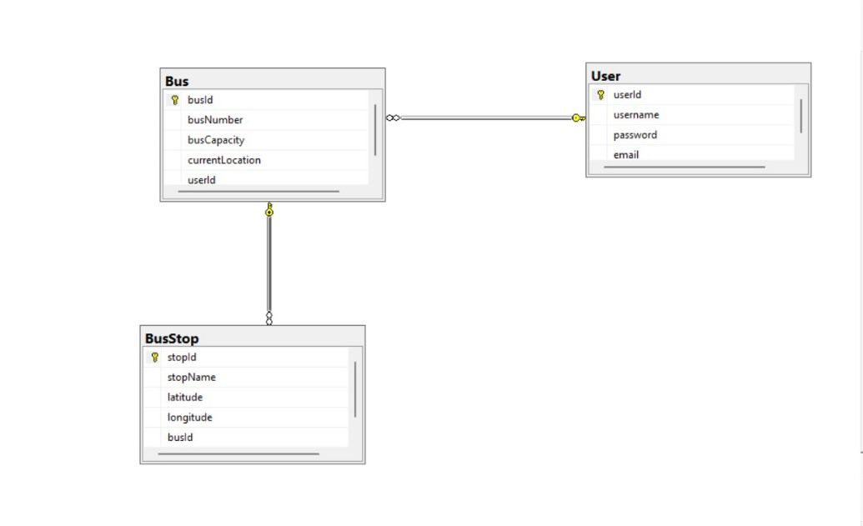

## 5.6Architecture Design

1.Presentation Layer:

* Mobile Application: This layer includes a mobile application that serves as the user interface. It provides features such as finding the nearest bus stops, checking bus schedules, and making ticket reservations.

2.Application Layer:

* User Management Module: This module handles user registration, login, and profile management.
* Bus Tracking and Scheduling Module: This module tracks buses in real-time using GPS or other tracking technologies, optimizes bus routes based on factors like passenger demand and traffic conditions, and manages bus schedules.
* Payment and Fare Management Module: This module integrates with payment gateways to enable online ticket purchases and manages fare calculation and payment processing.
* Feedback and Rating Module: This module allows users to provide feedback, ratings, and comments on their travel experiences.
* Admin Management Module: This module provides administrative functionalities for managing users, bus operators, schedules, fares, and system settings.

3.Business Logic Layer:

* User Service: Implements business logic related to user management, authentication, and profile management.
* Bus Service: Implements business logic for bus tracking, scheduling, and route optimization.
* Payment Service: Handles payment-related functionalities, including integration with payment gateways and fare calculation.
* Feedback Service: Manages user feedback, ratings, and comments.
* Admin Service: Provides administrative functionalities for system management.

4.Data Layer:

* Database: Stores user information, bus tracking data, schedules, fares, feedback, and other relevant data.

## Graphical User Interface Design(GUI)

|  |
| --- |
|  |
|  |
|  |
|  |
|  |

# 6.0

6.1 GUI code

<div style="position: relative; width: 100%; height: 0; padding-top: 62.5000%; padding-bottom: 0; box-shadow: 0 2px 8px 0 rgba(63,69,81,0.16); margin-top: 1.6em; margin-bottom: 0.9em; overflow: hidden; border-radius: 8px; will-change: transform;"> <iframe loading="lazy" style="position: absolute; width: 100%; height: 100%; top: 0; left: 0; border: none; padding: 0;margin: 0;" src="https:&#x2F;&#x2F;www.canva.com&#x2F;design&#x2F;DAFkkUf8VKc&#x2F;view?embed" allowfullscreen="allowfullscreen" allow="fullscreen"> </iframe></div><a href="https:&#x2F;&#x2F;www.canva.com&#x2F;design&#x2F;DAFkkUf8VKc&#x2F;view?utm_content=DAFkkUf8VKc&amp;utm_campaign=designshare&amp;utm_medium=embeds&amp;utm_source=link" target="_blank" rel="noopener">******</a> by Omar Azizieh

## 6.2 database implementation

|  |
| --- |
|  |
|  |
|  |

# 7.0 user manual

1. A screenshot of a login screen

   Description automatically generated with low confidenceChoose a way to Sign in, either Credit card or Bus card

1. Fill in your Credit card information.

1. Fill in your bus card information.
2. A picture containing text, screenshot, font, diagram

   Description automatically generatedOnce you've logged in you need to set your destination and set your location, then it will show you the estimated time for the nearest buses, route and estimated fare.

, Don't forget to give us feedback and rate our services.

# 

# 8.0 References: books and tools

* Staruml
* MySQL
* Chatgpt
* Adobe xd
* Canva
* https://www.canva.com/design/DAFkkUf8VKc/-ZpIHmQEMu4L3poWAgzp1w/view?mode=prototype